## MATERIAL USED AND THERE DIMENSIONS

Table shows the six major components that make the system run. The material and dimensions of the components are shown below:

## Table : Material Specifications

|  |  |  |
| --- | --- | --- |
| **NAME** | **DIMENSIONS** | **MATERIAL** |
| CISTERN | 430×290×120 mm | POLYPROPYLENE |
| BASE or PLATFORM | 540×490 mm | WOOD |
| SUPPORTING STAND | 770 mm | MILD STEEL |
| SPRING | 6 inch | TEMPERED STEEL |
| STRIKING LEVER WITH RUBBER END | Striking Lever Length= 110mm | MILD STEEL |
| Rubber Length= 45mm |
| Thickness= 5mm |
| BOLTS  (Full Threaded) | Length= 9 inch | MILD STEEL |
| Diameter= 12mm |

## COST ANALYSIS

The total cost incurred in the model is illustrated in the table below:

## Table : Cost of Model

|  |  |
| --- | --- |
| **MATERIAL** | **COST(Rs)** |
| SPRING | 140 |
| CISTERN | 300 |
| BOLT | 110 |
| WOOD | 500 |
| WELDING | 1000 |
| STAINLESS STEEL SQUARE PIPES | 800 |
| MISCELLANEOUS | 500 |
| **TOTAL** | **3350** |

# CONSTRUCTION

Construction of the system is simple and efficient. It does not have any complicated arrangement. The operation of the arrangement is fully mechanical. Steps involved in fabricating are:

## MAIN PARTS USED IN THE CONSTRUCTION

* Platform Making
* Cistern Fitting
* Motion Transmitting Lever

### Platform Making

Platform is made of wood. It is a replica of originally used Indian toilet. In our design of platform we have used 12 numbers of springs, rectangular wood (54 x 49) cm in the figure given below. This platform is arranged by attaching 4 bolts of 9 inch length and 12 mm diameter each, these are attached at four corner of wood. In the middle of the two wood pattern springs are arranged in parallel arrangement in three rows.

### Cistern Fitting

Cistern is fitted by attaching metal plate with lower part of the platform. It is given a minimum height of 760 mm. To the cistern a continuous water supply line is connected. Cistern contains a floating ball and manually pressed handle .When water in the container crosses maximum limit floating ball prevents further flowing of water in the inlet. When handle is pressed discharge of water occurs.

### Motion Transmitting Lever

It is a square hollow pipe which is attached on the upper part of the platform by making a bracket and thereby screwing it up. This motion transmitting lever is connected to another small thin lever by arc welding. This thin lever is drilled and attached to the cistern frame with the help of a screw. At the end portion of the lever a synthetic rubber band is used having thickness 5 mm .The end portion of the thin lever having synthetic rubber at the end touches the handle and pressed it whenever people gets off from the platform.

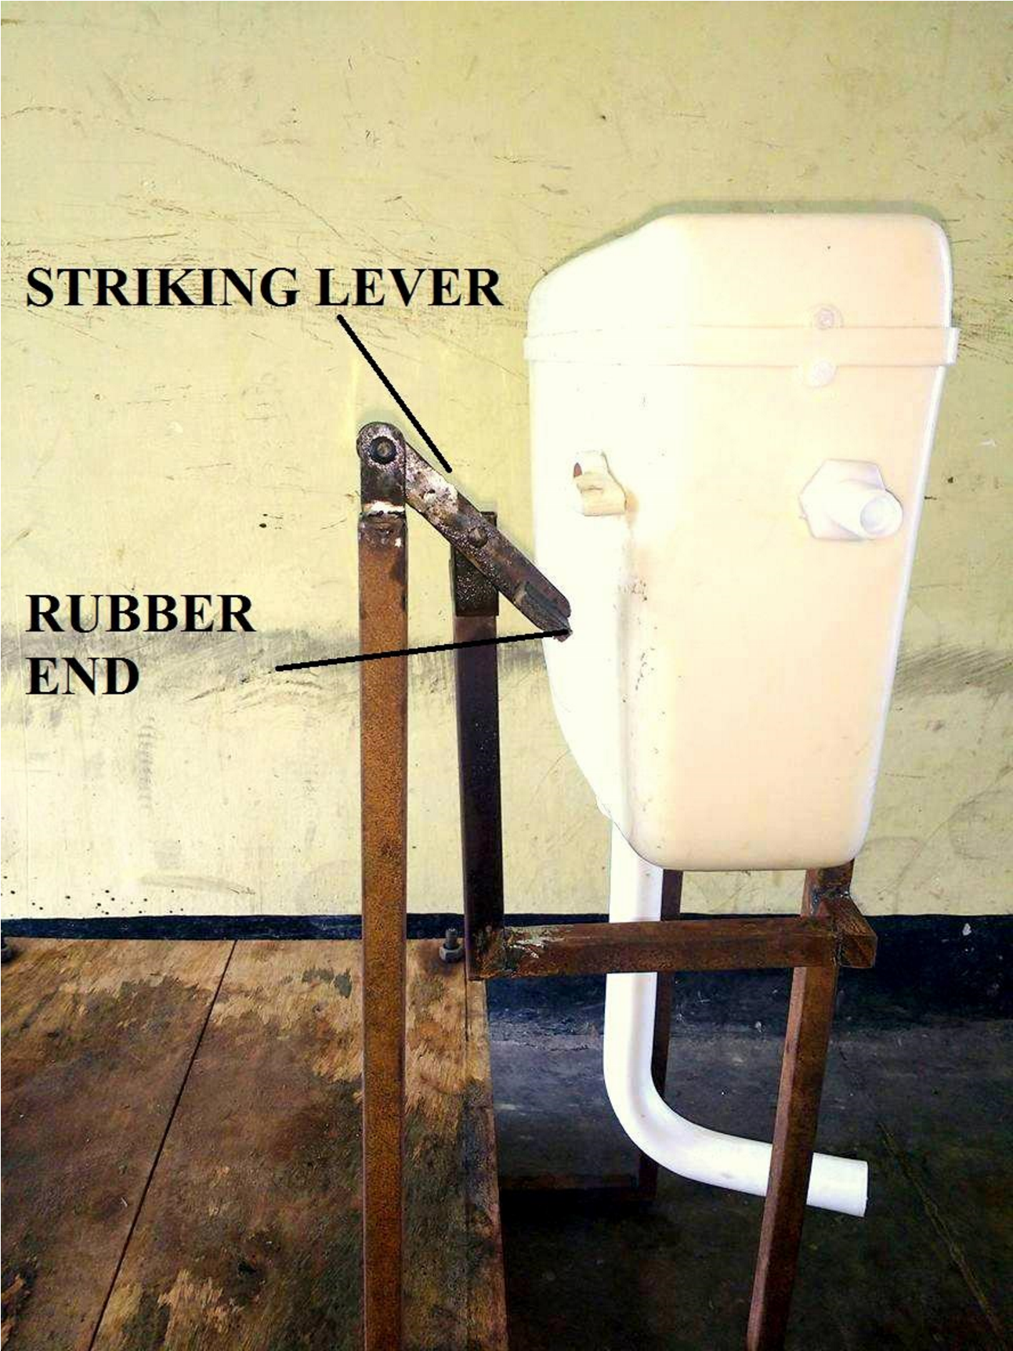

## Figure : View of the Lever

# WORKING OF SMART TOILET FOR AUTOMATIC FLUSHING

## WORKING PRINCIPLE

The working principle of the mechanism is very simple which uses only mechanical means (such as springs, levers etc.) for its functioning. The wooden platform is consisting of two halves, one movable and the other fixed, both having springs between them. It mainly works on the principle of spring compression and expansion. When force is applied on spring, it gets compressed and after removal of the force, because of spring stiffness it provides a reaction force in opposite direction. The vertical steel pipe attached to the upper half of the base also moves up and down along with it. As a result due to lever mechanism the flexible element attached to the tip of the lever moves up crossing the cistern handle. All the arrangements work together and provide us automatic flushing from cistern.

## WORKING OF EVERY ITEM USED IN OUR SYSTEM

* Platform working
* Cistern working
* Lever working

### Platform Working

Platform is nothing but spring mass system arrangement. It is the main part of our developed project where people will sit for toilet and thus compressing the spring attached in it. So when the person lifts off from the platform because of spring stiffness platform will try to comeback to original position and thus allowing an upward automatic movement of the platform.

### Cistern Working

The cistern contains a handle, an inlet valve and a float rod with float ball at the end. The inlet is mainly controlled by float ball whereas outlet is controlled by handle attached on the cistern. When handle is pressed in downward direction outlet valve opens and discharge takes place.

### 4.2.3 Lever Working

There are total two levers attached on our system which do the function on the following manner:-

* *Motion transmitting lever*: Motion transmitting lever is directly attached on the upper part of platform. Upward motion of platform is first transmitted to motion transmitting lever which pushes the 2nd lever attached on it in upward direction and net effect is converted into downward direction.
* *Lever with synthetic rubber at the end*: The lever having synthetic rubber at the end is connected by bolt joint to the motion transmitting lever. The end this lever is grooved and synthetic rubber is attached which touches the handle of the cistern. Thus handle of the cistern is pushed in downward direction by rubber and providing an automatic flush from the cistern.

## DIFFERENT POSTIONS OF LEVER

Following figures illustrate different load condition and their respective position of lever.

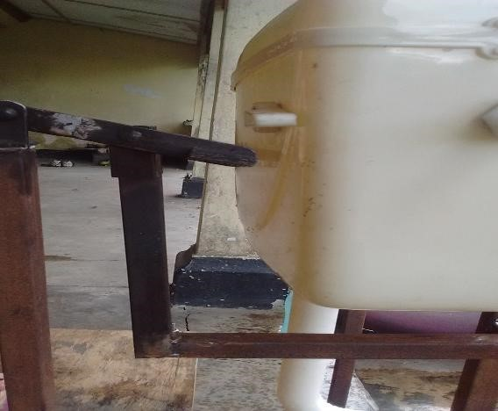

## Figure : Position of Lever When Load is not applied

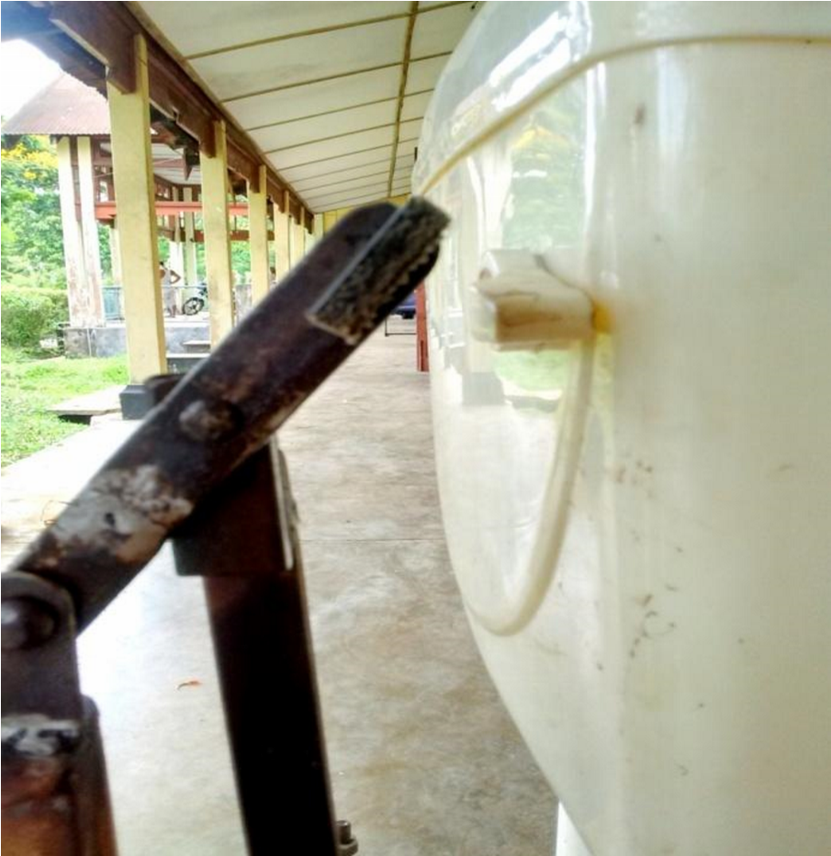

## Figure : Position of Lever When Load is applied

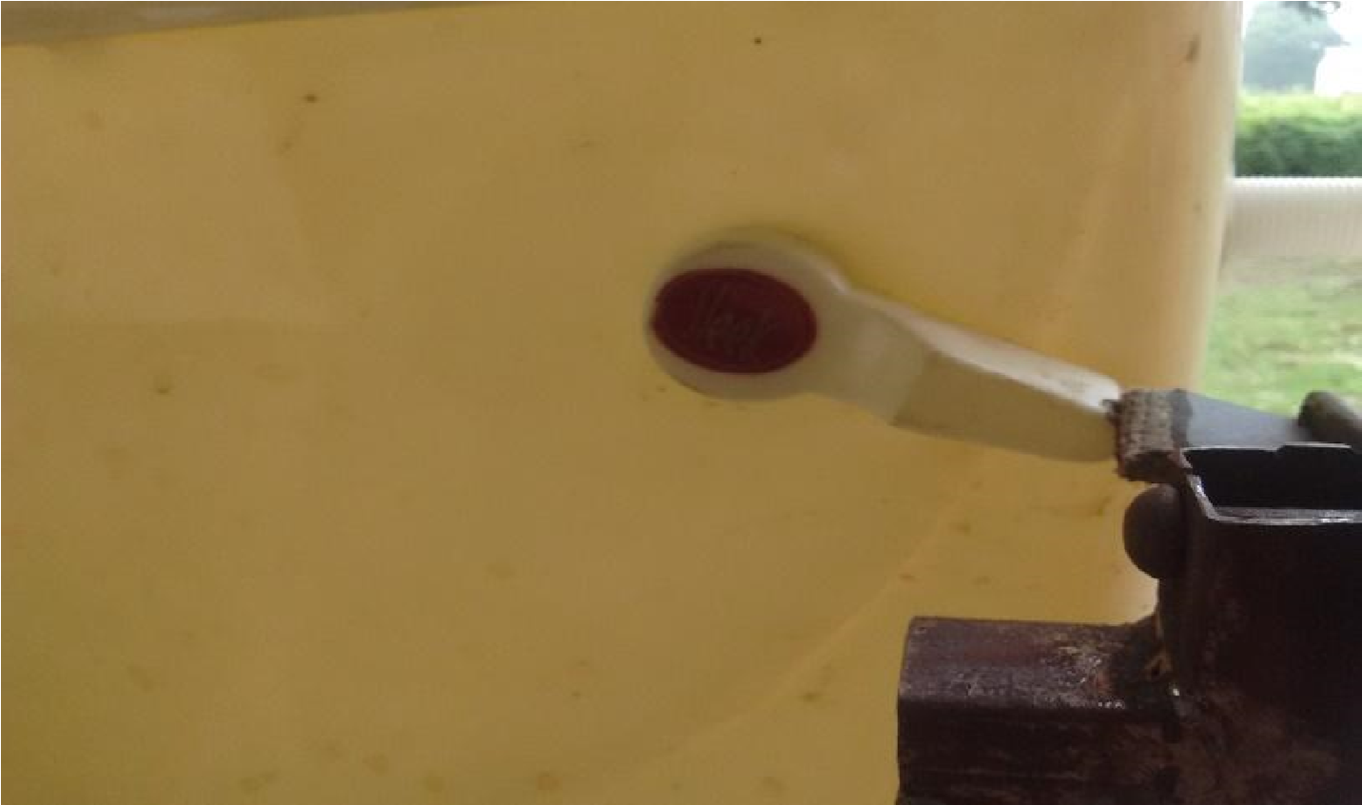

## Figure : Position of Lever While the Load is removed

# CALCULATIONS AND RESULTS

## DIFFERENT PARAMETERS INVOLVED

While developing the mechanism some experiments were performed to calculate the spring stiffness (which are used in the platform), minimum deflection for varying load, discharge capacity, flow velocity etc. which were required for constructing the mechanism. The calculations and the results are presented in the following tables.

### Experiment for Determination of Spring Stiffness

The experiment was performed by placing different loads on the upper half of the platform and then measuring the corresponding deflection .The spring stiffness is obtained by the formula**:**

|  |
| --- |
| Spring Stiffness (k) = Force/deflection |

EQUIVALENT SPRING CONSTANT:

In the platform the springs are arranged in 3*4 arrays. All the springs are connected in parallel so the equivalent spring constant of the arrangement can be obtained as follows:

Let the spring constant of each spring be K and the equivalent spring constant is K1.

Therefore,

|  |
| --- |
| K1 = 12×K Hence, K = K1/12 |

## TABLE : Spring Stiffness Calculation

|  |  |  |  |
| --- | --- | --- | --- |
| SL. NO. | FORCE  (kg) | DEFLECTION  (cm) | SPRING  STIFFNESS(kg/cm) |
| 1 | 30 | 5.8 | 5.17 |
| 2 | 40 | 7.7 | 5.19 |
| 3 | 50 | 9.6 | 5.2 |
| 4 | 55 | 10.5 | 5.23 |
| 5 | 60 | 11.5 | 5.21 |

## Calculations:

Average spring stiffness, K1= (5.17+5.19+5.2+5.23+5.21) ÷5 = 5.2 kg/cm

Spring stiffness of each spring, K= 5.2/12

= 0.433 kg/cm

Minimum deflection corresponding to a load of 20 kg= 20/5.2=3.85 cm

### Flow Velocity Calculation

## Table : Average Discharge Calculation

|  |  |  |  |  |
| --- | --- | --- | --- | --- |
| SL.NO. | DISCHARGE  ( m 3) | TIME  TAKEN(sec) | AVERAGE  TIME  (sec) | RATE OF  DISCHARGE(m3/sec) |
| 1 | 11×10-3 | 12.3 | 60.3/5 =12.06 | .000912 |
| 2 | 11.7 |
| 3 | 11.9 |
| 4 | 12.1 |
| 5 | 12.3 |

Cross sectional area at the outlet = π/4 ×.032 =.000707 m2

Average outlet flow velocity =

|  |
| --- |
| Rate of discharge/Area at the outlet |

= 0.129 m/s

# 

# DIFFERENT VIEWS OF THE MODEL

In this chapter we have provided different views of the overall project. They are shown below.

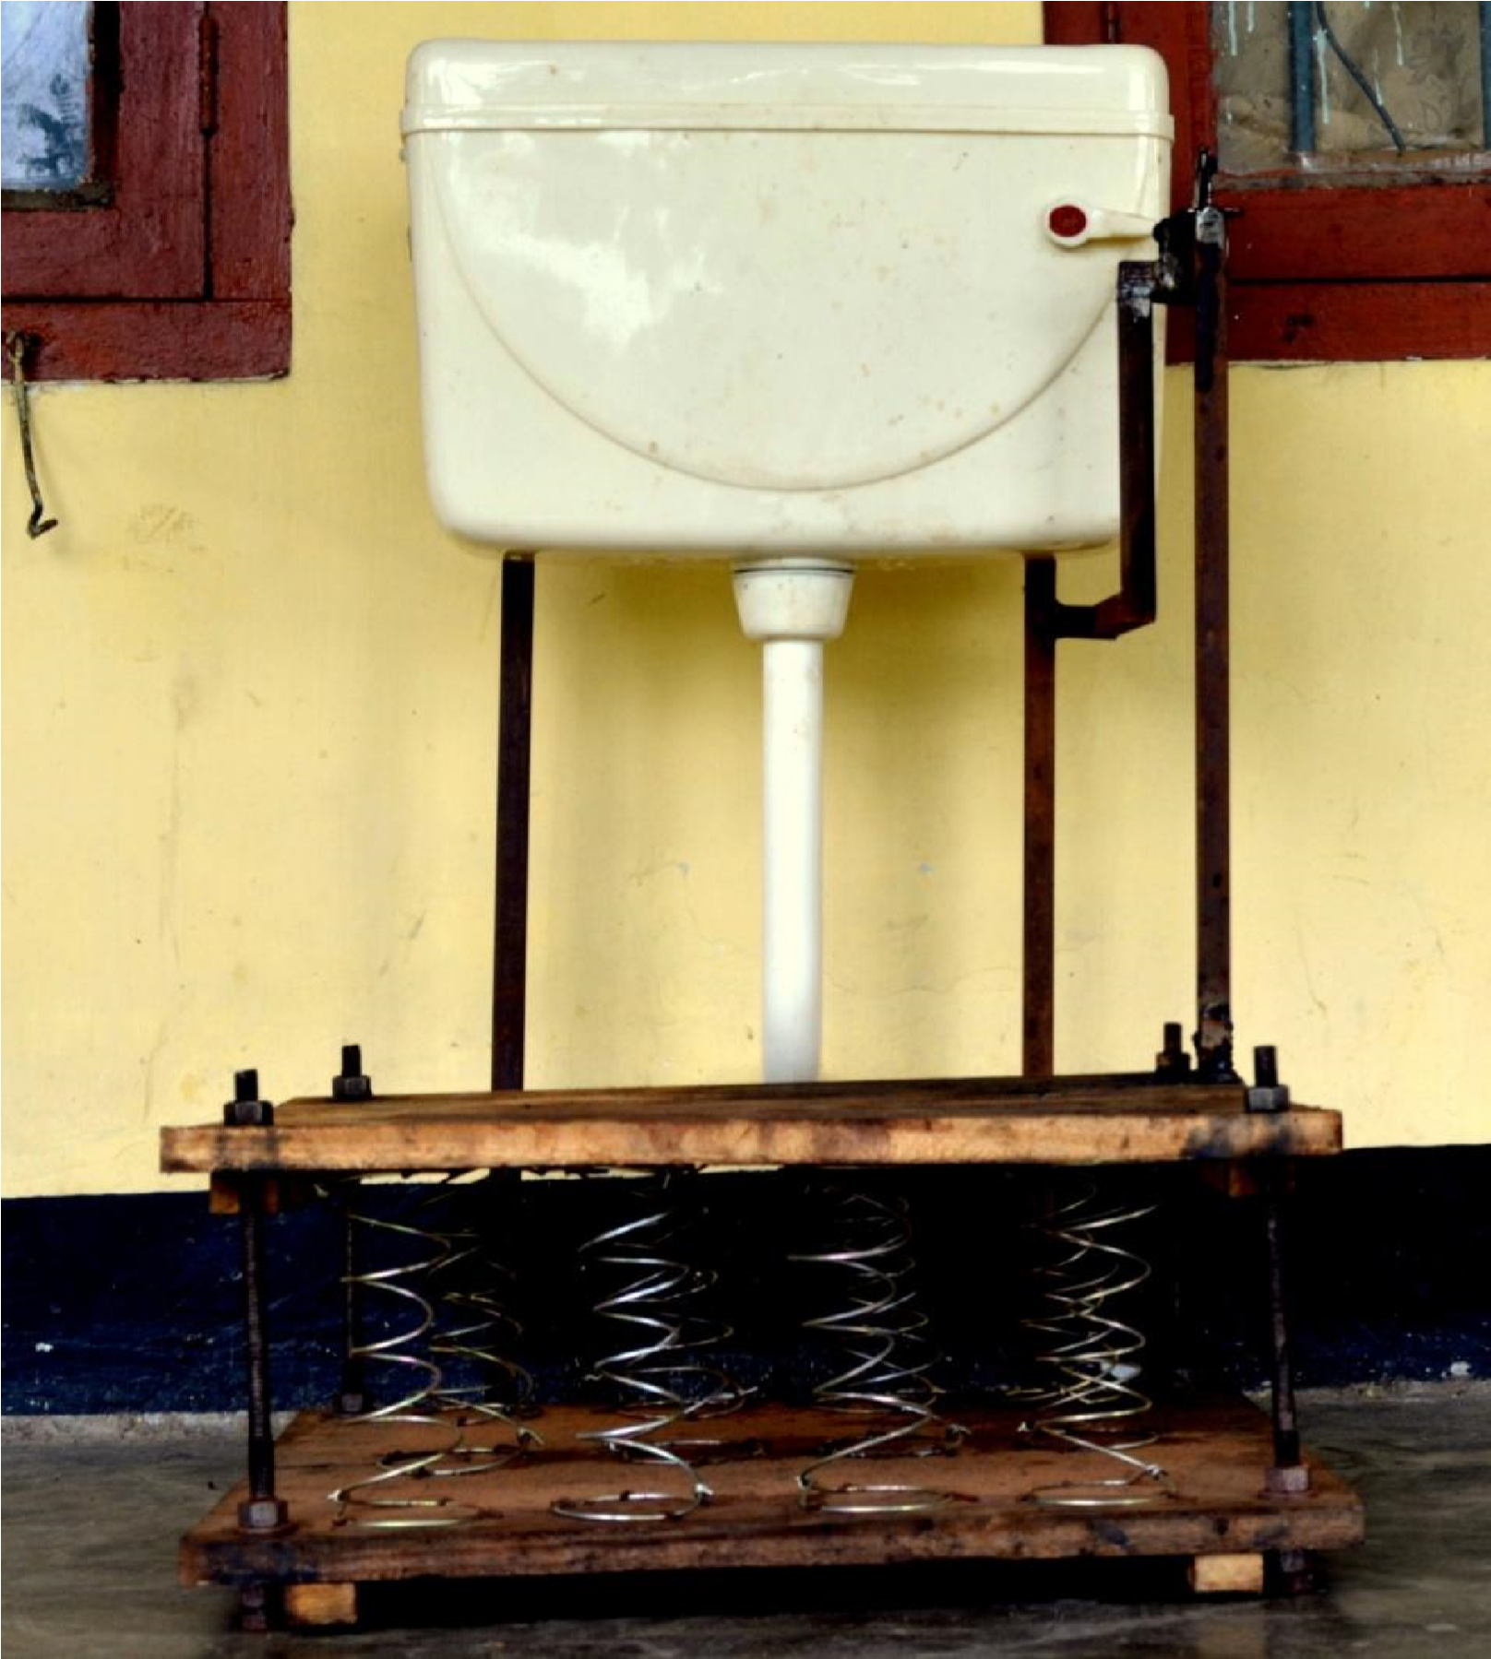

## Figure : Front View of the Model

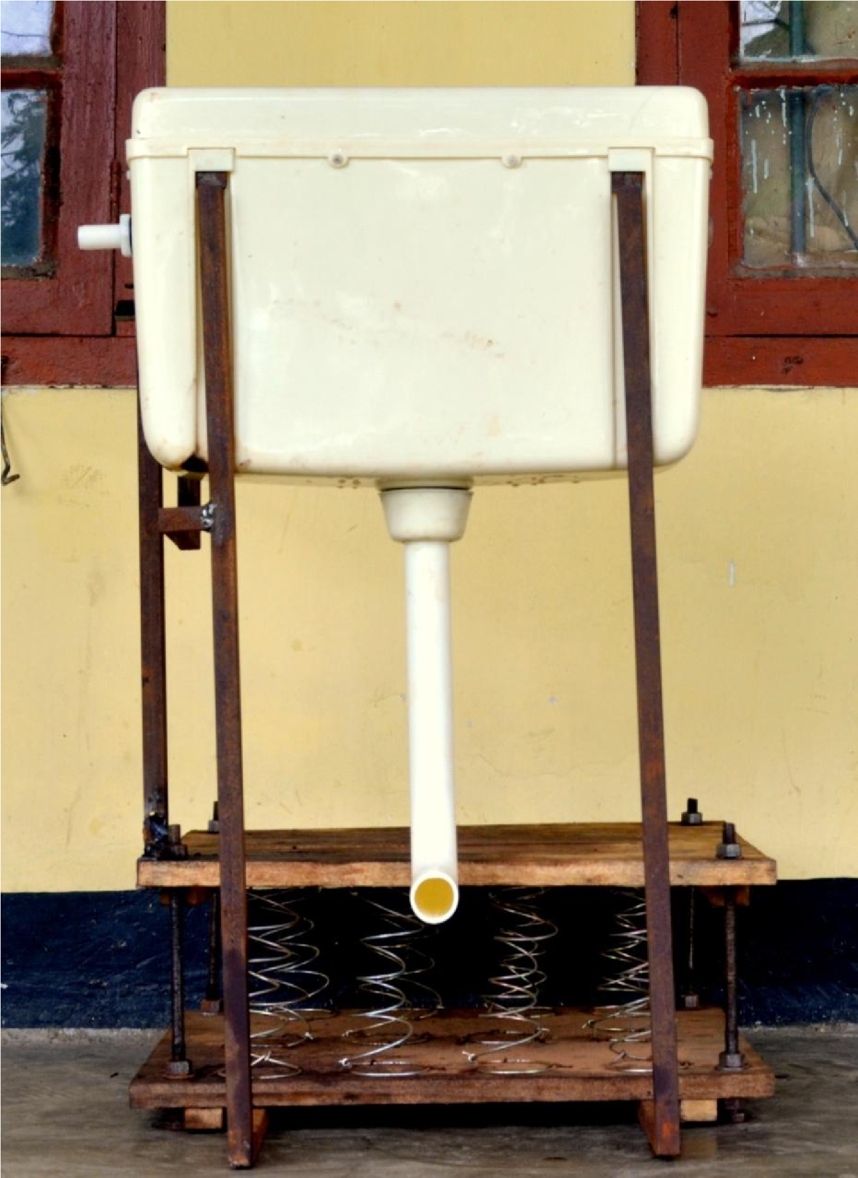

## Figure : Rear View of the Model

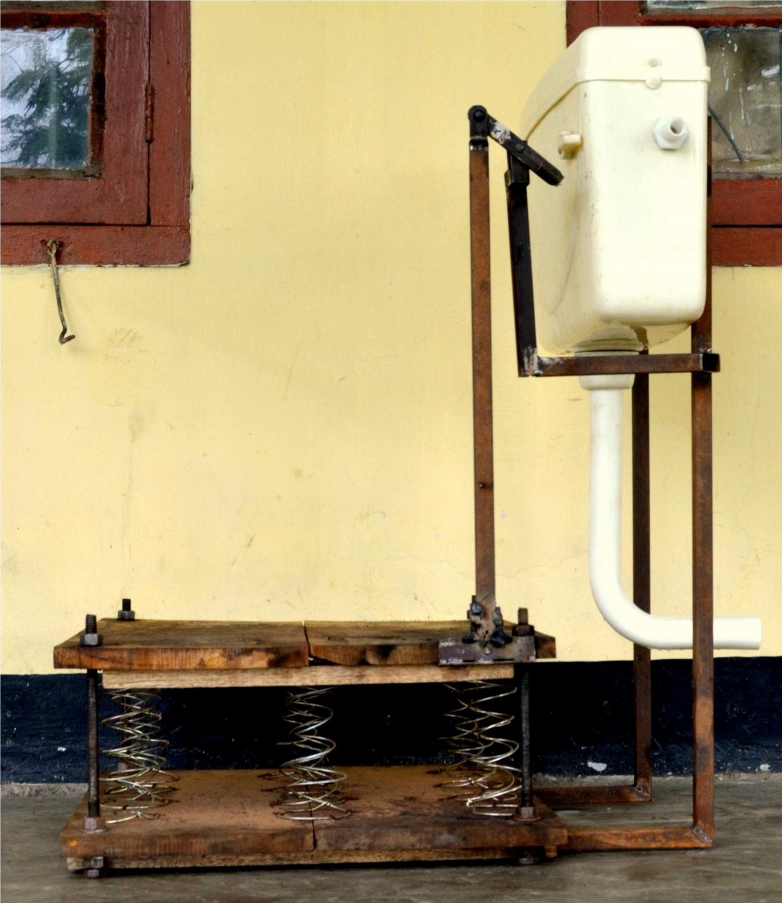

## Figure Right Hand Side View of the Model

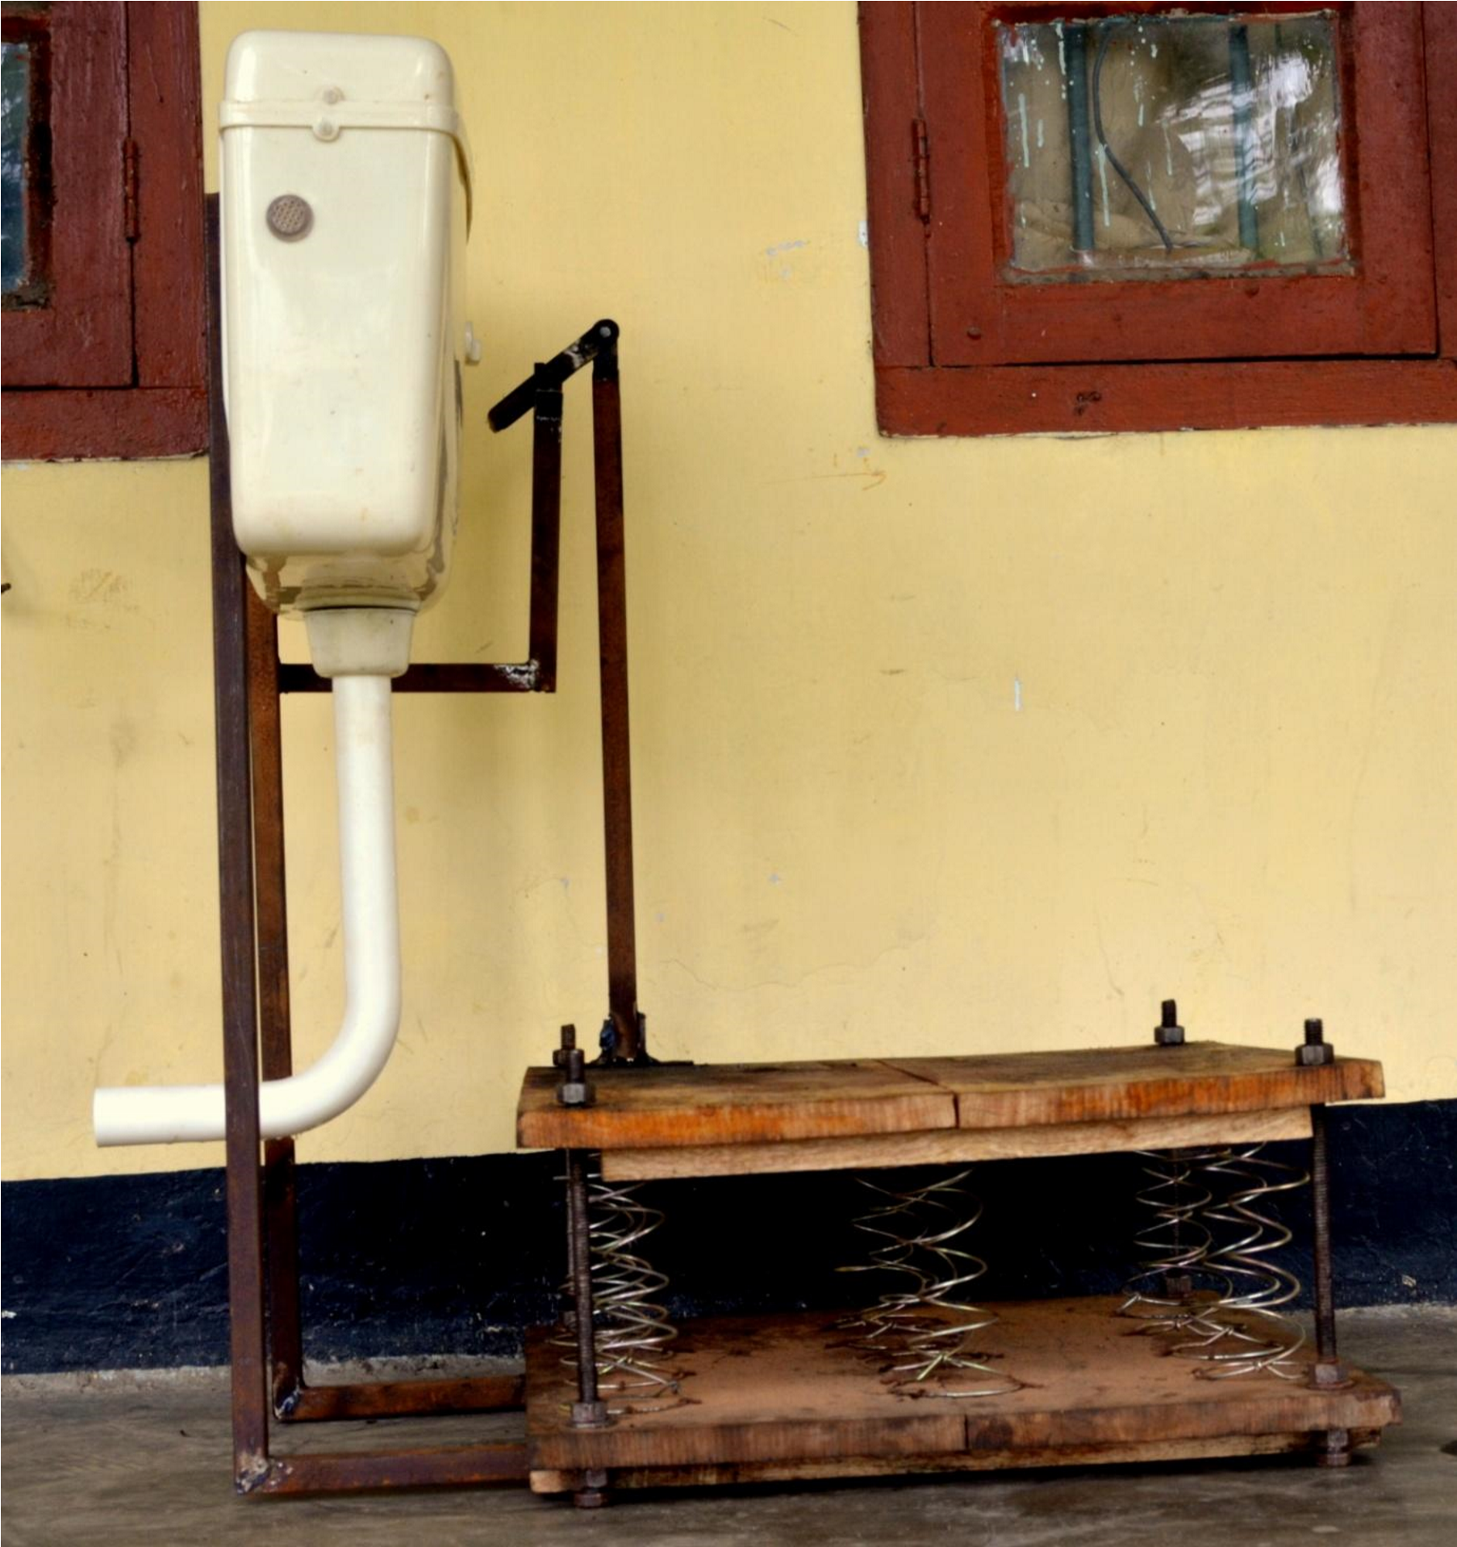

## Figure : Left Hand Side View of the Model

# 

# CONCLUSION

## CONCLUSION

The entitled project ***Development of a Smart Toilet for Automatic Flushing*** aims to achieve a more cleaner and hygienic public toilet system in rural, semi urban and urban areas in the near future. We want to broadcast the project as a public welfare initiative. In rural areas, there is scarcity of electric power and hence our design will be best suitable. This design utilizes the weight of the person in flushing the toilet and hence is a rather simple mechanism. This project is aimed to contribute to the Central Government Scheme of “Swachh Bharat Abhiyan” where each and every citizen of the nation is entitled to have a cleaner and hygienic future.

## FUTURE SCOPE

The present work is successful in the view that the proposed mechanism has been successfully designed and demonstrated; but there is still a lot of room for further improvement which may include the following:

* In the project, the platform is unstable, i.e. it does not hold still when a person mounts or dismounts it. Therefore it could be made more stable by providing bushing instead of bolts to constraint the motion.
* The currently constructed platform is a wooden one and can be replaced with a steel platform so that welding the lever would be easier rather than to screwing it up.
* The levers can be arranged in other suitable positions to make the working more efficient.
* The metal attachment that is used to work the flush switch can be replaced by more efficient methods like by another lever arrangement with fulcrum or a cam.
* With more testing and calculation, the design of the developed mechanism can be improved further and implemented in the concerned areas.